|  |
| --- |
| [Type the company name] |
| SAAD USMAN |
| BCSP#243016 |

|  |
| --- |
| ztech  [Pick the date] |

LAB 6

TASK 1:

Beef-xss

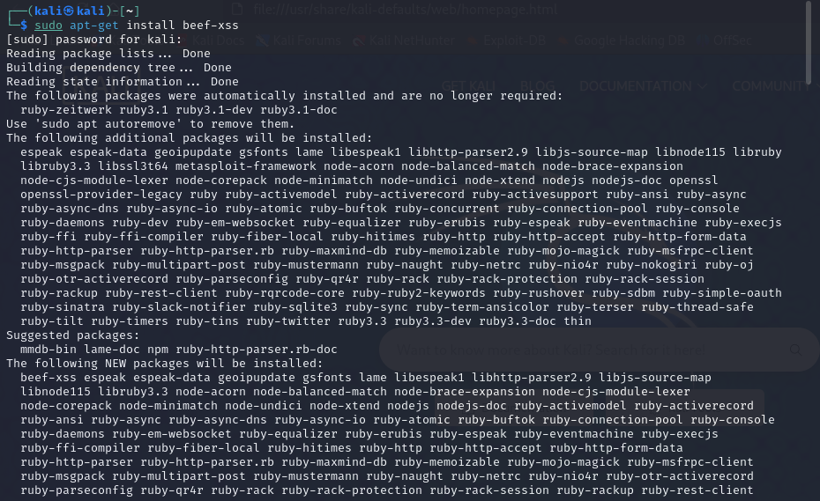

TASK 2:

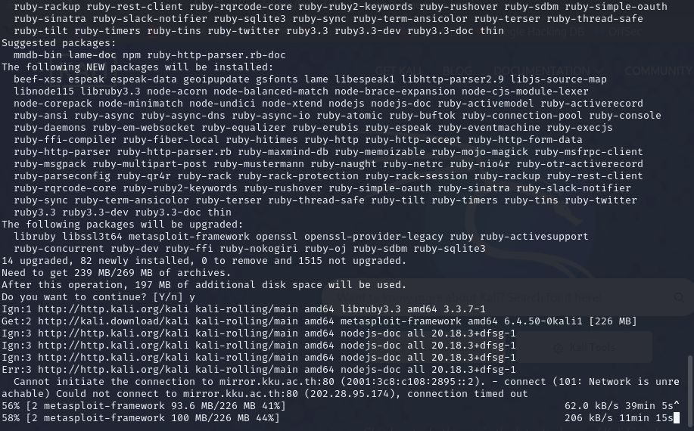

Task 3:

Successfully install beef ,now we clone up

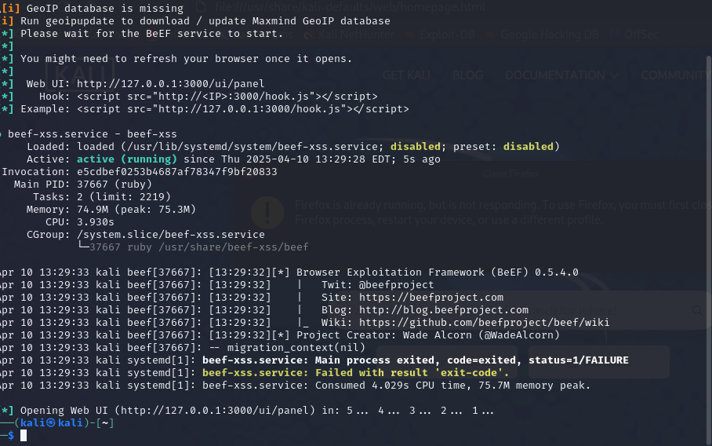

TASK 4:

DONE CLONING

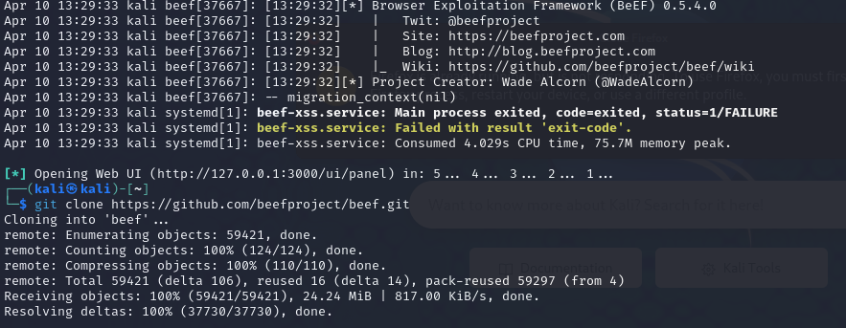

TASK 5:installing cd beef

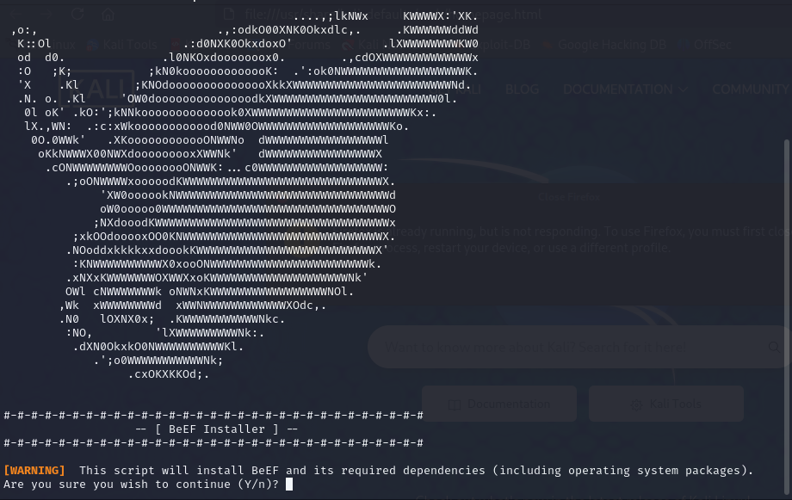

Task 6:

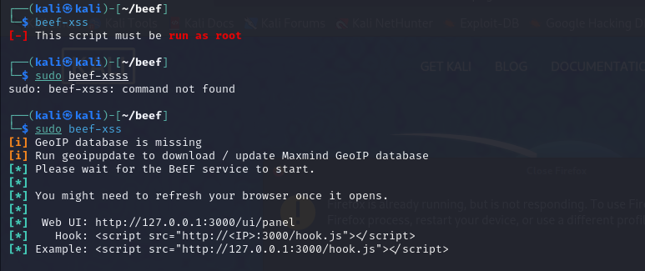

Task 7:

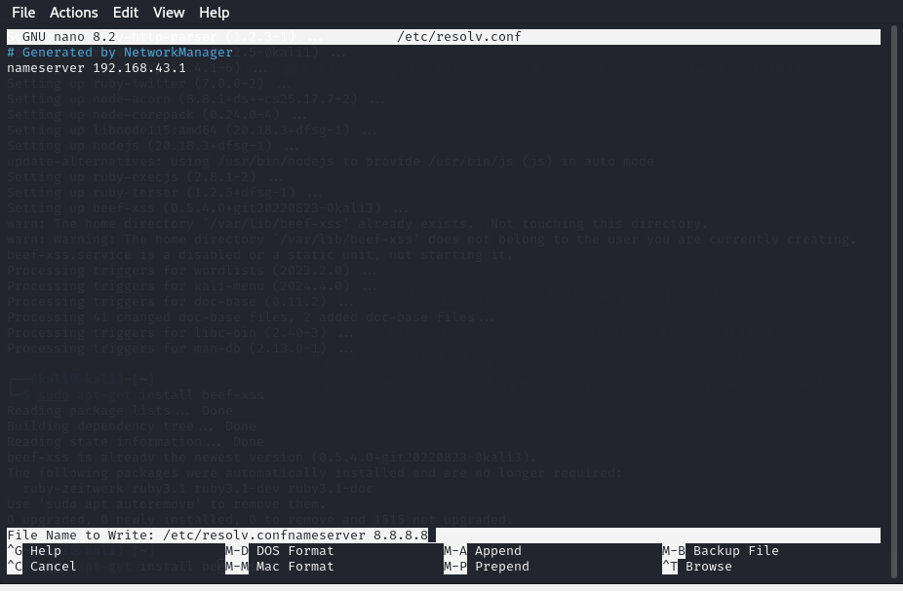

From here I have run multiple commands but it is not resolving .

sudo systemctl restart NetworkManager

ping -c 3 google.com

bundle install

**I have also done manually but nothing happened.**

sudo nano /etc/resolv.conf

nameserver 8.8.8.8

ping rubygems.org